Ecological and Economic Sustainability of Agricultural Land
and its Benefits for Investors

(and how to gain personal advantage from it)

Ing. Viktor Harnach
Businessman, investor and collector

Contact details:
603 470 4130
https://www.harnach.cz/
https://www.investicnipozemky.eu/
https://www.zlatosambicemi.cz/
https://www.to-nevymyslis.cz/

Goals:
- Provide information on yet neglected investment class – agricultural land
- Arouse interest in this investment opportunity yet undiscovered by investors
- Achieve a legitimate profit by the seminar participants as a result of their successful investments
- Contribute to the promotion and sustainability of farming production and care for the landscape in the Czech Republic (and in the surrounding areas of Central Europe)

Content:
- Putting the issue in context in terms of the location and time
- Comparison of the development in the former socialist countries (where collectivisation and subsequent privatisation took place) with the countries that have been developing in a standard way
- Consequences of collectivisation and subsequent privatisation
- What are the implications (advantages) for us as investors – individuals with legitimate private interests
- Financial magic

Specification:
- Person of the lecturer
- Agricultural land in the Czech Republic

Putting the issue in context in terms of its location: a map of Central Europe with the same crop area marked

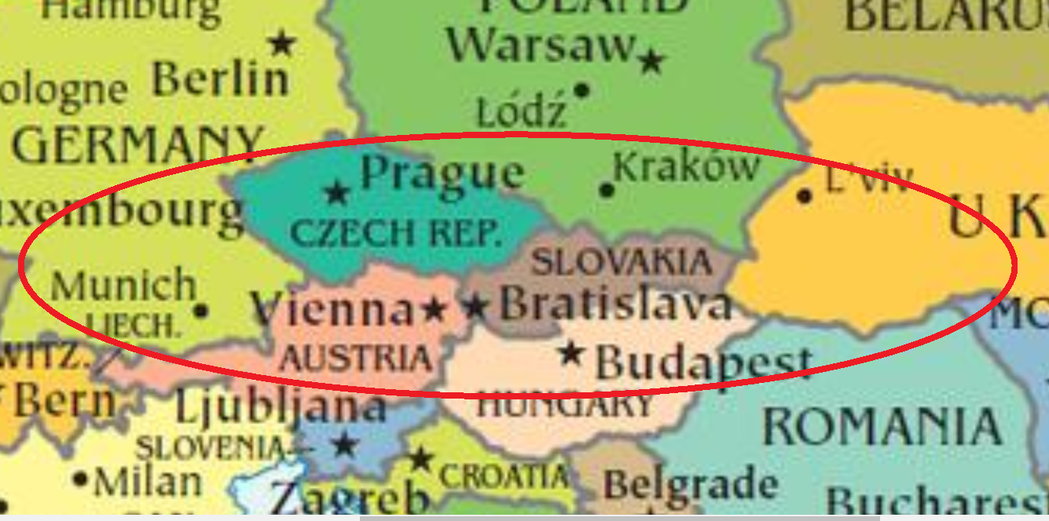

Time frame:
- The 1950s – 1980s – Period of collectivisation
- The 1990s – Restitution
- After the year 2000

Ad 1.: Collectivisation:
- Consolidation of land, erasing the boundaries by ploughing, straightening the watercourses, wetland drainage. The communist motto read, “We will rule the wind and rain.”
- Loss of personal motivation of farmers for the ecological and economic sustainability of their activities
- Loss of the market mechanisms and its replacement by planned parameters (prices set by state)
- Beginnings of large-scale production
- Use of fertilisers, increase in per hectare yield
- Centuries-old traditions of agricultural production on family farms broken, personal ties to the land lost, switching of profession from agricultural to industrial, leaving the country and moving to the city, etc.
- Defining the demand for food self-sufficiency
- Maintaining detailed records of land that was seized and used for collective farming

Ad 2.: The 1990s – Restitution
- Socialist large-scale production rejected and people returned to private farming
- Demand for food self-sufficiency dismissed
- Restitution of agricultural property on the basis of the preserved records of land seized and used for collective farming
- End of state-regulated purchase prices of agricultural products, rising costs (of fertilisers, fuels, etc.)
- Arrival of foreign retail chains that do not buy from local farmers and dictate prices
- Opening the market to non-European agricultural producers - a consequence of globalisation
- End of economic sustainability of agricultural entrepreneurs
- End of naive agricultural enthusiasts who recovered land in restitution but were not rooted in a well-proven tradition of agricultural production, had a lack of business and economic know-how, etc.
- Threats to the ecological sustainability of landscape maintenance
- Sale of agricultural land at prices of CZK 1.75
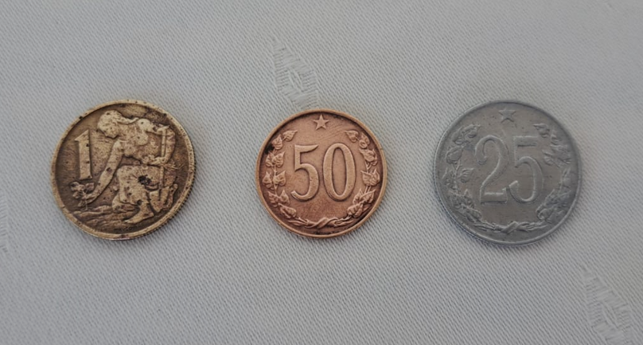
Ad 3.: After y. 2000:
- No demand for food self-sufficiency
- Unsustainability of agricultural production and landscape maintenance – loss of governments´ motivation
- Farmers who failed leave the sector and sell their land for ridiculous prices
- Increasing pressure to turn farmland into building land, roads, solar farms, etc.
- Requirements of Western European and later all farmers to receive subsidies

Differences between established, traditional, West European farmers and “new” farmers farming on land recovered in restitution:

West European farmers:
- Proven know–how,
- Land mostly cultivated by generations of ancestors, inherited, paid off long time ago
- Already established technological base, machinery, fertilizers, etc.
- Established supplier-customer relations - interest of their domestic business chains
- Significant influence on politicians and government officials
- Measures in place (or being introduced) to protect the agricultural commodities market
- Current price of agricultural land (Bavaria, Austria, etc.) – between EUR 5-6/ m2

Result? A stable sector based on well-proven traditions and values, good skills and qualifications, financial strength and political support.

Differences between established, traditional, West European farmers and “new” farmers farming on land recovered in restitution:

“East European” farmers:
- Fragmentation of agricultural production in response to the post-socialist large-scale production, which did not prove successful.
- Only partial know-how "inherited" from the previous era
- Poor availability of capital
- Poor know-how in business and economy
- Obsolete machinery
- Agriculture has lost the attention of political leaders - farmers have lost political influence
which is not true for “agrofertisation” /translator´s note: a Czech term for the process of favouring the business empire Agrofert owned by the ex-PM Andrej Babis/
- Average price of land between CZK 35 – 50/m2
- Fragmented land ownership structure among the people who recovered land in restitution and their heirs

Result? Broken sector, damaged by the loss of identity, loss of traditions, lack of know-how, capital, political backing, etc. Austrian and Bavarian farmers buy or lease Czech agricultural land within driving distance of the borders and farm it.

Price development in agricultural land:
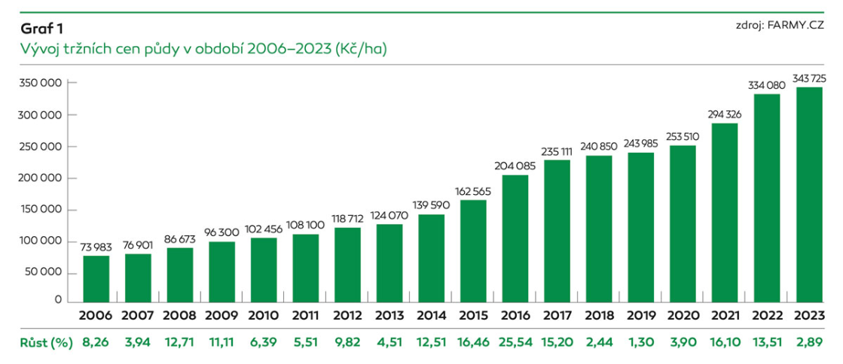

In addition to this, there has been stable price growth even in times when stocks and shares were falling.

Calculation of the rate of return on agricultural land:
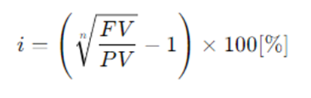
i = internal rate of return on price increases over the period under review
n = number of periods (years)
FV = price at the end of the monitored period
PV = price at the start of the monitored period
The result is calculated as a percentage (average annual growth).

Three remarks:
- This means an annual return to the landowner which is made up only of the change in market price and does not take into account at all the returns from agricultural production and the costs of achieving them, rent, etc.
- Regular rent (rent paid for lease) is around 1% of the land price - unaffordable for farmers » majority of Czech farmers farm on leased land
- It is profitable for Bavarian and Austrian farmers within the driving distance to rent or purchase land in the Czech Republic

Calculation of the average annual return made by agricultural land in possession:

Period | No. of years | Average annual return for the period (%) | Period | No. of years | Average annual return for the period (%)
1994 – 2023 | 29 | 10,80 | 1994 – 2024 | 30 | 10,77
2006 – 2023 | 17 | 9,52 | 2006 – 2024 | 18 | 9,55
2013 – 2023 | 10 | 10,71 | 2014 – 2024 | 10 | 10,49
2018 – 2023 | 5 | 7,31 | 2019 – 2024 | 5 | 9,09

Comments:
- The assumed value of CZK 37.7/ 1 m2 is used for the calculation for the year 2024 (not yet finished).
- The trend of price development towards equal prices of land in the Czech Republic and Bavaria and Austria (CZK 37/1 m2 in the CR compared to EUR 5-6/1 m2).
- Uncertain forecast of the development in agriculture and the development of the prices of agricultural land in Ukraine.

It makes a great sense to invest in agricultural land!
Investors can reasonably expect an average return of around 10% annually!
The same trend in prices of agricultural land as in Bavaria and Austria can be expected.
In addition, there may be more interested parties as a result of the development in Ukraine
However:
There is a limited area of agricultural land and it is still vanishing!
There is too little agricultural land to cover investors´ needs!
It is necessary to solve the relationship with the lessee, take care of the collection of the rent, etc.
Property tax must also be paid.
It must be taken into account that further development may not be exactly as expected, but may develop differently.

A tool to invest in agricultural land:

- Investment in land registered in the Land Register
- For 5 years (can be extended or shortened)
- At the end of the 5-year period, the sale of the land is resolved!
- Guaranteed return of 10% per year
- Possibility of additional return
- Minimum amount to invest: CZK 500,000
- Relationship with the lessee resolved
- The interest of investors in agricultural land has not yet been aroused!
- We currently (2024) have agricultural land for investors´ needs.

The full document is available for download: https://www.investicnipozemky.eu/Dokumenty/16_Přednáška 17.9.2024 or here

Concluding remark: except for the internal rate of return formula, nothing in this paper has been created by using the AI; it is entirely the product of the author.

In Prague, on 17.9.2024
Ing. Viktor Harnach
Businessman, investor and collector

Contact details:
603 470 4130
https://www.harnach.cz/
https://www.investicnipozemky.eu/
https://www.zlatosambicemi.cz/
https://www.to-nevymyslis.cz/

